Annual Report 2016

Foreword
2016 was a very busy year for COPD Support Ireland (COPDSI) as it continued to grow and develop as a national patient-led organisation. By the end of our third year, we had some significant achievements. For the second year in a row we were recognised for our innovative work by the Medical Times Awards. This time as a category winner in partnership with Roche for the video about COPD staring Betty Sutton. The short video was developed for social media as an educational tool about living with COPD and it received over 100,000 hits.
COPD SI’s advocacy work grew steadily throughout the year, with increasing numbers of people living with COPD continuing to seek assistance on a range of issues including, general advice and information on diagnosis and living with COPD, medical card advice and supporting applications for medical cards, increased electricity bills for oxygen users and inappropriate housing. The establishment of the COPD Adviceline in 2016, a Freephone service operated by healthcare professionals was a very welcome addition to our services. The adviceline offers professional advice Monday to Friday on the management of COPD.
Betty Sutton a founding member of COPD Support Ireland and a leader of the local Bray COPD Support group sadly passed away in late 2016. Betty was a fantastic advocate for people living with COPD and we offer our deepest condolences to her family.
It has been an honour to serve as Chair of COPD Support Ireland for the past 3 years. My heartfelt thanks, to all our supporters and volunteers around the Country for your involvement and support. Grateful also to all Board members for your stewardship of such a worthwhile organisation. Finally, grateful to Damien Peelo who has worked strenuously to bring COPDSI to the current stage of development, the details of which you can read in this report. My thanks also, to Wendy, who was a wonderful support for the various support groups around the Country.
My thanks to all,

Introduction
COPD Support Ireland (COPDSI) is a national organisation, led by people living with COPD, set up to to raise awareness of and support those living with Chronic Obstructive Pulmonary Disease (COPD), and to advocate for action to tackle and prevent the disease. COPD SI is a young, growing and ambitious organisation established in 2013. Working with our members, we will create greater awareness of COPD in Ireland, support better services and ultimately improve the life of people living with COPD.
Our Vision Statement
That people living with COPD live the life they want to live
Our Mission Statement
COPD Support Ireland is an advocacy and support organisation, driven by people living with COPD. Its mission is to maximise the quality of life of people living with or at risk of COPD and to support those who care for them.

The activities and actions reported in this document are all intended to reach our vision and mission statement and are part of a three-year strategic plan, 2014 to 2017.

Raise Awareness of COPD
Raising awareness of Chronic Obstructive Pulmonary disease among the general population was a key strategy pursued by COPD SI in 2016. More than 380,000 people in Ireland have COPD but only 110,000 are diagnosed with the illness. We also know that early diagnosis is critical in preventing the worst effects of the onset of COPD. COPD SI invested resources in developing a communications plan which set out actions and targets to increase the level of information about COPD across Ireland. Key actions included:

- COPD SI’s website provides information about the disease and provided an update portal with key information and a range of resources for people with COPD. A sub site was also developed to profile and spread the crucial campaign ‘Save Your Breath’ which was updated for World COPD Week 2016.

- World COPD week was a huge success as we held our first ever patient conference in Dublin which was attended by over 130 people living with COPD. The conference was launched by Minister of State for Health Promotion, Marcella Corcoran Kennedy TD. The conference keynote speakers Ross Morgan from Beaumont Hospital and David Hevey from TCD gave excellent talks on the management of COPD and mental health and COPD. Our COPD Ambassador Anna Nolan compered the conference and hosted the political discussion with 6 TDs in attendance.
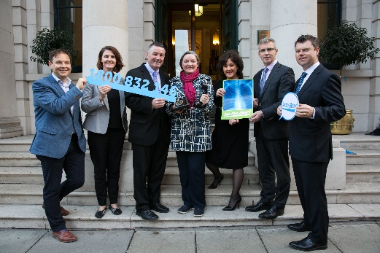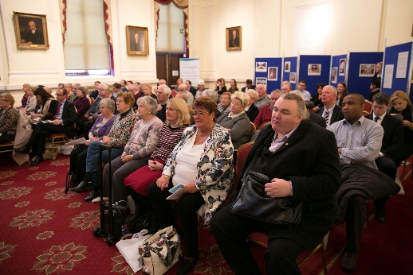
Launch the adviceline Conference delegates

- We provided hospital packs for World COPD Week to all the acute hospitals to build local community-based responses and provide information about COPD. A series of promotional events were delivered including, ‘Save your Breath’ campaign and the placement of articles and information in a range of media for example, medical journals, radio interviews on community based radios.

- Spirometry testing was provided for members of the Irish Traveller Community in the South Dublin area. 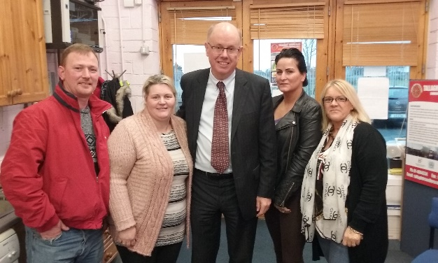 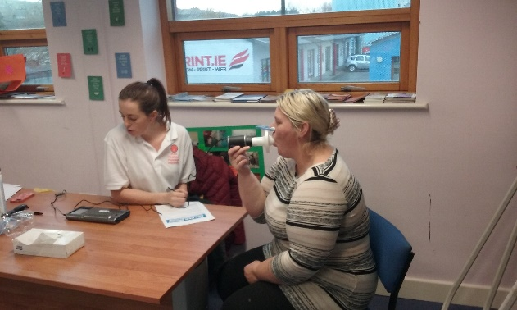
Prof. Tim McDonnell at Tallaght Travellers Testing in the Traveller Centre
Publications
A COPD Inhaler poster was developed by our Health Committee and supported by Menarini. The poster provides details of the inhalers used in the treatment of COPD to health care professionals. Over 5,000 posters were distributed to hospitals and GP’s and is due for reprint in 2017/
Public Awareness:
National radio campaign
COPD ran a national campaign to enhance the public knowledge of COPD and encourage vaccinations for winter, supported by Novartis. This involved a radio advertisement run over 3 weeks and voiced by the CEO of COPD Support Ireland asking to people to be Winter Ready.
Education and Development
- Held a joint education event with Asthma Society sponsored by Menarini on the topic of COPD and Asthma overlap syndrome. 40 Health Care Professionals attended.
Health Impact Survey
- Carried out an online survey with 130 people on their lived experiences of COPD including diagnosis, treatment and quality of life. Results are due to be published in 2017.

Department of Communications Energy and National Resources
- We provided information on the Departments Warmer Homes Scheme to members, community groups, churches and local health centres in Dublin 12 and 24 areas. The scheme provides an upgrade in home insulation and heating for people living with COPD who meet the eligibility criteria.
Breathe life in Christmas
A national competition was held in December encouraging people with COPD to enter an image that represented their view of Christmas time living with COPD. A photocall was held announcing the start of the competition and received coverage in print media. The winners of the competition nominated local COPD Support groups to receive a cash prize.
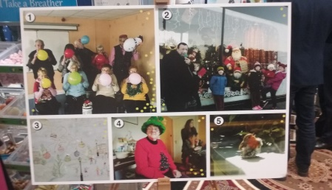
Christmas Photo winner Runners up

The Development of our Membership
COPD SI is committed to the development of strong local member groups to enable community-based responses to emerge in addressing self-management, lack of awareness of COPD and lack of policy responses to COPD. This work ensures that a collective patient-led response to this disease can be developed.
In 2016 five new groups were supported to set up and by the end of the year there were 15 active member groups in Galway, Dublin Ballyfermot, Dublin North, Dublin Huntstown, Limerick, Cork. Mullingar, Louth, Mayo, Sligo, Thurles, Nenagh, Waterford, Clare and Bray.
COPD SI provided templates focusing on:
- Constitution for a local group,
- Role of COPD Support Group
- Roles and functions of committee
- Agenda setting
- Financial procedures and management
During the year the groups agreed to function as part of the national body and make annual returns to the charity regulator as one entity under COPD Support Ireland.

National Forum for Members:

Three national meetings were held in 2016 in Portlaoise in March and June and in Athlone October. These meetings are critical spaces for members to exchange information, share experiences, influence national policy and contribute to the planning of national strategies and events.
In 2016 the outcomes from the meetings included:
- Patient Conference for World COPD Week developed
- COPD Model of Care document produced by the National COPD Clinical Programme had patient input
- Decision on the type of national structure that would support the local groups to function as affiliated members of COPD Support Ireland.
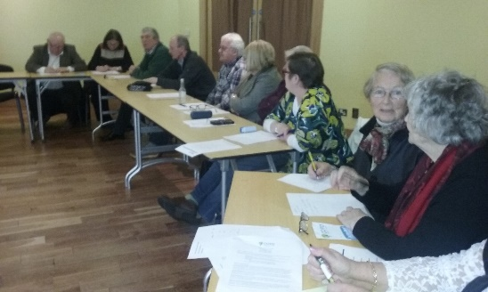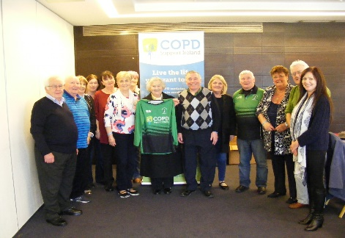
Portlaoise meeting Athlone meeting

To Effect Change
COPD SI is committed to effecting change in decision-making processes and forming partnerships with other to influence positive changes in the delivery of care and in policy responses. In 2016, COPD SI:
- Manifesto: The COPD manifesto was republished to pursue our 5 key asks for COPD care and treatment. This was widely circulated to all political parties and many independents. It was also circulated to local support groups.
- In partnership with Asthma Society of Ireland and the HSE Primary Care Division launched a National COPD Adviceline for people living with COPD.
- In partnership with the COPD National Clinical Programme supported the roll out of the Integrated Care posts in xxxx (what areas were they rolled out in)
- Made submissions to key policy arenas for example Health Service Executive - National Medical Card Unit (NMCU) Strategic Plan & the Oireachtas Health Committee on the Future of Health Care Needs.
COPD SI continued its partnership work through:
- Active membership at a national level with:
  - Irish Lung Health Alliance,
  - Medical Research Charities Group,
  - IPOSSI,
  - National Patient Forum HSE,
  - Tobacco Control Partners Group.

- Active membership at an EU level through engagement with:
  - European Federation of Allergies and Airways Diseases,
  - European COPD Coalition.

An Ethical, Transparent and Sustainable Organisation
COPD SI is a registered charity, CHY 20731 and is a company limited by guarantee.
COPD SI is governed by a Board of Directors made up of 5 representatives from our member patient groups, 5 representatives from the Healthcare Professions, 3 members from the business community and 2 members from Community and Voluntary Sector.
COPD SI seeks to develop an inclusive organisational structure, procedures and sustainable funding streams to enable it to achieve its aims in an ethical and transparent manner.
In 2016 it advanced this through:
- Holding an AGM and ensuring Company requirements were met.
- Policy regarding the relationship between COPD Support Ireland accepting funds from donors was developed.
- Pursuit of implementation of the good governance code
- The fundraising strategy was progressed

There are a number of sub committees of the board:
- Health Subcommittee
- Fundraising Subcommittee
- Finance and Personnel

COPD Support Ireland Board of Directors 2016
Bernard O'Sullivan | Patient Representative
Tommy Kearns | Patient Representative
Ann Murphy | Patient Representative
Michael McGloin | Patient Representative
Michael Drohan | Patient Representative
Michael O'Shea | Com &Vol Representative and Chairperson
Suzanne McCormack | Com & Vol Representative
JJ Gilmartin | Healthcare Professional Representative
Máire O’Connor | Healthcare Professional Representative
Ursula Reilly | Healthcare Professional Representative
Ruth Findlater | Independent

Fundraising
COPD Support Ireland prioritised fundraising in 2016 running two major fundraising events. It linked this work to generating significant public awareness about COPD by maximising traditional and social media.
Get Breathless for COPD inaugural cycle from Galway to Dublin in June with over 50 participants raised over €18,000. It achieved coverage in national and regional media print, radio and online. The cycle was supported by AMenarini.
The Women’s Mini Marathon grew in strength with over 40 participants wearing the COPD t-shirts and raising in excess of €8000 for our services.
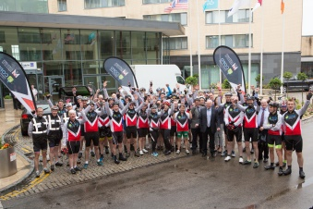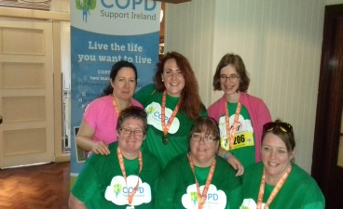
Menarini ‘Save your breath’
Cycle, Hodson Bay Hotel

Financial Report
COPD Support Ireland’s annual accounts from January to December 2016.
Auditors for 2016 were Murphy Accountants Dublin.
Company Number: 548142
COPD Support Ireland Company Limited by Guarantee
Directors' Report and Financial Statements
for the year ended 31 December 2016

CONTENTS
 | Page
Directors and Other Information | 3
Directors' Report | 4 - 5
Directors' Responsibilities Statement | 6
Independent Auditor's Report | 7
Income and Expenditure Account | 8
Balance Sheet | 9
Reconciliation of Members' Funds | 10
Cash Flow Statement | 11
Notes to the Financial Statements | 12 - 14
Supplementary Information on Trading Statement | 16 - 20

Directors | Ursula Clarke
 | Michael Drohan
 | Ruth Findalter
 | J.J. Gilmartin
 | Tommy Kearns
 | Michael McGloin
 | Suzanne McCormack
 | Ann Murphy
 | Marie O'Connor
 | Michael O'Shea
 | Bernard O'Sullivan
Company Secretary | Suzanne McCormack
Company Number | 548142
Registered Office | Office 35
 | Brookfield House
 | Brookfield Terrace
 | Blackrock
 | Dublin
Auditors | Gerard T Murphy & Company
 | 60 Springfield Avenue
 | Dublin 6W
 | Republic of Ireland

Bankers | Bank of Ireland
 | Ballsbridge
 | Dublin 4

The directors present their report and the audited financial statements for the year ended 31 December 2016.
Principal Activity and Review of the Business
is to provide assistance and support to people who suffer from chronic pulmonary disease ("COPD"), their carers and families by promoting the development of local support groups, raising awareness of COPD, supporting research and representing the needs of people with COPD at relevant statutory and other agencies.
The Company is limited by guarantee not having a share capital.
There has been no significant change in these activities during the year ended 31 December 2016.

Principal Risks and Uncertainties
The company is overly reliant on funding from the pharmaceutical industry and the principal risk is a decrease in the level of that income. The directors continue to manage this risk by closely monitoring income levels and activity pursuing funding.
Financial Results
The surplus for the year amounted to €16,264 (2015 - €3,383).
At the end of the year the company has assets of €59,549 (2015 - €34,975) and liabilities of €14,286 (2015 - €5,976). The net assets of the company have increased by €16,264

Directors and Secretary
The directors who served throughout the year, except as noted, were as follows:
Ursula Clarke
Michael Drohan
Ruth Findalter
J.J. Gilmartin
Tommy Kearns
Michael McGloin
Suzanne McCormack
Ann Murphy
Marie O'Connor
Michael O'Shea
Bernard O'Sullivan
The secretary who served throughout the year was Suzanne McCormack

In accordance with the Articles of Association, the directors retire by rotation and, being eligible, offer themselves for re-election.

Future Developments
The company plans to continue its present activities and current trading levels. Employees are kept as fully informed as practicable about developments within the business.

Post Balance Sheet Events
There have been no significant events affecting the company since the year-end.

Auditors
The auditors, Gerard T Murphy & Company have indicated their willingness to continue in office in accordance with the provisions of Section 383(2) of the Companies Act, 2014.

Taxation Status
The company is a close company within the meaning of the Taxes Consolidation Act, 1997.

Accounting Records
To ensure that adequate accounting records are kept in accordance with Sections 281 to 285 of the Companies Act 2014, the directors have employed appropriately qualified accounting personnel and have maintained appropriate computerised accounting systems. The accounting records are located at the company's office at Office 35, Brookfield House, Brookfield Terrace, Blackrock, Dublin.
Signed on behalf of the board
Suzanne McCormack
Director
Michael Drohan
Director
21 June 2017

The directors are responsible for preparing the Directors' Report and the financial statements in accordance with applicable Irish law and regulations.
Irish company law requires the directors to prepare financial statements for each financial year. Under the law the directors have elected to prepare the financial statements in accordance with the Companies Act 2014 and FRS 102 "The Financial Reporting Standard applicable in the UK and Republic of Ireland" issued by the Financial Reporting Council and promulgated by the Institute of Chartered Accountants in Ireland. Under company law, the directors must not approve the financial statements unless they are satisfied that they give a true and fair view of the assets, liabilities and financial position of the company as at the financial year end date and of the surplus or deficit of the company for the financial year and otherwise comply with the Companies Act 2014.

In preparing these financial statements, the directors are required to:
- | select suitable accounting policies for the company financial statements and then apply them consistently;
- | make judgements and estimates that are reasonable and prudent;
- | state whether the financial statements have been prepared in accordance with applicable accounting standards, identify those standards, and note the effect and the reasons for any material departure from those standards; and
- | prepare the financial statements on the going concern basis unless it is inappropriate to presume that the company will continue in business.
The directors are responsible for ensuring that the company keeps or causes to be kept adequate accounting records which correctly explain and record the transactions of the company, enable at any time the assets, liabilities, financial position and surplus or deficit of the company to be determined with reasonable accuracy and enable them to ensure that the financial statements and directors' report comply with the Companies Act 2014 and enable the financial statements to be audited. They are also responsible for safeguarding the assets of the company and hence for taking reasonable steps for the prevention and detection of fraud and other irregularities.

Signed on behalf of the board
Suzanne McCormack
Director
Michael Drohan
Director
21 June 2017

We have audited the financial statements of COPD Support Ireland Company Limited by Guarantee for the year ended 31 December 2016 which comprise the Income and Expenditure Account, the Balance Sheet, the Reconciliation of Members' Funds, the Cash Flow Statement, the Accounting Policies and the related notes. The relevant financial reporting framework that has been applied in their preparation is the Companies Act 2014 and FRS 102 "The Financial Reporting Standard applicable in the UK and Republic of Ireland" issued by the Financial Reporting Council and promulgated by the Institute of Chartered Accountants in Ireland.
This report is made solely to the company's members, as a body, in accordance with Section 391 of the Companies Act 2014. Our audit work has been undertaken so that we might state to the company's members those matters we are required to state to them in an auditor's report and for no other purpose. To the fullest extent permitted by law, we do not accept or assume responsibility to anyone other than the company and the company's members as a body, for our audit work, for this report, or for the opinions we have formed.
Respective responsibilities of directors and auditors
As explained more fully in the Directors' Responsibilities Statement, the directors are responsible for the preparation of the financial statements and for being satisfied that they give a true and fair view and otherwise comply with the Companies Act 2014. Our responsibility is to audit and express an opinion on the financial statements in accordance with Irish law and International Standards on Auditing (UK and Ireland). Those standards require us to comply with the Auditing Practice Board's Ethical Standards for Auditors.

Scope of the audit of the financial statements
An audit involves obtaining evidence about the amounts and disclosures in the financial statements sufficient to give reasonable assurance that the financial statements are free from material misstatement, whether caused by fraud or error. This includes an assessment of: whether the accounting policies are appropriate to the company's circumstances and have been consistently applied and adequately disclosed; the reasonableness of significant accounting estimates made by the directors; and the overall presentation of the financial statements. In addition, we read all the financial and non-financial information in the Directors' Report to identify material inconsistencies with the audited financial statements and to identify any information that is apparently materially incorrect based on, or materially inconsistent with, the knowledge acquired by us in the course of performing the audit. If we become aware of any apparent material misstatements or inconsistencies we consider the implications for our report.

Opinion on financial statements
In our opinion the financial statements:
- | give a true and fair view of the assets, liabilities and financial position of the company as at 31 December 2016 and of its results for the year then ended; and
- | have been properly prepared in accordance with the relevant financial reporting framework and, in particular, the requirements of the Companies Act 2014.

Matters on which we are required to report by the Companies Act 2014.
- | We have obtained all the information and explanations which we consider necessary for the purposes of our audit.
- | In our opinion the accounting records of the company were sufficient to permit the financial statements to be readily and properly audited.
- | The financial statements are in agreement with the accounting records.
- | In our opinion the information given in the Directors' Report is consistent with the financial statements.

Matters on which we are required to report by exception
We have nothing to report in respect of the provisions in the Companies Act 2014 which require us to report to you if, in our opinion, the disclosures of directors' remuneration and transactions specified by Sections 305 to 312 of the Act are not made.
GERARD T MURPHY & COMPANY
60 Springfield Avenue
Dublin 6W
Republic of Ireland
21 June 2017

Income | 4 | 111,199 |  | 96,601
Expenditure |  | (94,935) |  | (93,218)
 |  | ─────── |  | ───────
Total Comprehensive Income |  | 16,264 |  | 3,383

 |  | ═══════ |  | ═══════
The company has no recognised gains or losses other than the surplus for the year. The results for the year have been calculated on the historical cost basis. The company's income and expenses all relate to continuing operations.
Approved by the board on 21 June 2017 and signed on its behalf by:
Suzanne McCormack
Director
Michael Drohan
Director

 |  |  | 2016 |  | 2015
 |  | Notes | € |  | €
Current Assets
Debtors |  | 6 | 18,540 |  | 21,316
Cash and cash equivalents |  |  | 41,009 |  | 13,659
 |  |  | ─────── |  | ───────
 |  |  | 59,549 |  | 34,975
 |  |  | ─────── |  | ───────
Creditors: Amounts falling due within one year |  | 7 | (14,286) |  | (5,976)
 |  |  | ─────── |  | ───────
Net Current Assets |  |  | 45,263 |  | 28,999
 |  |  | ─────── |  | ───────
Total Assets less Current Liabilities |  |  | 45,263 |  | 28,999
 |  |  | ═══════ |  | ═══════
Reserves
Income and expenditure account |  |  | 45,263 |  | 28,999
 |  |  | ─────── |  | ───────
Equity attributable to owners of the company |  |  | 45,263 |  | 28,999
 |  |  | ═══════ |  | ═══════

Approved by the board on 21 June 2017 and signed on its behalf by:
Suzanne McCormack
Director
Michael Drohan
Director

as at 31 December 2016
 | Retained | Total
 | surplus
 | € | €
At 1 January 2015 | 25,616 | 25,616
 | ─────── | ───────
Surplus for the year | 3,383 | 3,383
 | ─────── | ───────

At 31 December 2015 | 28,999 | 28,999
 | ─────── | ───────
Surplus for the year | 16,264 | 16,264
 | ─────── | ───────

At 31 December 2016 | 45,263 | 45,263
 | ═══════ | ═══════

Cash flows from operating activities
Surplus for the year |  | 16,264 | 3,383
 |  | ─────── | ───────
 |  | 16,264 | 3,383
Movements in working capital:
Movement in debtors |  | 2,776 | (21,316)
Movement in creditors |  | 8,310 | 2,185
 |  | ─────── | ───────
Cash generated from/(used in) operations |  | 27,350 | (15,748)
 |  | ─────── | ───────

Net increase/(decrease) in cash and cash equivalents |  | 27,350 | (15,748)
Cash and cash equivalents at beginning of financial year |  | 13,659 | 29,407
 |  | ─────── | ───────
Cash and cash equivalents at end of financial year | 12 | 41,009 | 13,659
 |  | ═══════ | ═══════

1. | GENERAL INFORMATION
 | COPD Support Ireland Company Limited by Guarantee is a company limited by guarantee incorporated in the Republic of Ireland. Office 35, Brookfield House, Brookfield Terrace, Blackrock, Dublin , is the registered office, which is also the principal place of business of the company. The nature of the company’s operations and its principal activities are set out in the Directors' Report. The financial statements have been presented in Euro (€) which is also the functional currency of the company.

2. | ACCOUNTING POLICIES
 | The following accounting policies have been applied consistently in dealing with items which are considered material in relation to the company’s financial statements.
 | Statement of compliance
 | The financial statements of the company for the year ended 31 December 2016 have been prepared on the going concern basis and in accordance with FRS 102 “The Financial Reporting Standard applicable in the UK and Republic of Ireland” (FRS 102). These are the company's first set of financial statements prepared in accordance with FRS 102. There have been no transitional adjustments made.
 | Basis of preparation
 | The financial statements have been prepared on the going concern basis and in accordance with the historical cost convention except for certain properties and financial instruments that are measured at revalued amounts or fair values, as explained in the accounting policies below. Historical cost is generally based on the fair value of the consideration given in exchange for assets. The financial reporting framework that has been applied in their preparation is the Companies Act 2014 and FRS 102 "The Financial Reporting Standard applicable in the UK and Republic of Ireland" issued by the Financial Reporting Council and promulgated by the Institute of Chartered Accountants in Ireland.
 | Income
 | Income consists of donations, fundraising and sponsorship.

Trade and other debtors
Trade and other debtors are initially recognised at fair value and thereafter stated at amortised cost using the effective interest method less impairment losses for bad and doubtful debts except where the effect of discounting would be immaterial. In such cases the receivables are stated at cost less impairment losses for bad and doubtful debts.

Trade and other creditors
Trade and other creditors are initially recognised at fair value and thereafter stated at amortised cost using the effective interest rate method, unless the effect of discounting would be immaterial, in which case they are stated at cost.

Employee benefits
The company operates a defined contribution pension scheme. The assets of the scheme are held separately from those of the company in an independently administered fund. The company also operates a defined benefit pension scheme for its employees providing benefits based on final pensionable pay. The assets of this scheme are also held separately from those of the company, being invested with pension fund managers.

Taxation and deferred taxation
no charge to current or deferred taxation arises as the company has been granted charitable status

Foreign currencies
Monetary assets and liabilities denominated in foreign currencies are translated at the rates of exchange ruling at the Balance Sheet date. Non-monetary items that are measured in terms of historical cost in a foreign currency are translated at the rates of exchange ruling at the date of the transaction. Non-monetary items that are measured at fair value in a foreign currency are translated using the exchange rates at the date when the fair value was determined. The resulting exchange differences are dealt with in the Income and Expenditure Account.

3. | DEPARTURE FROM COMPANIES ACT 2014 PRESENTATION
 | The directors have elected to present an Income and Expenditure Account instead of a Profit and Loss Account in these financial statements as this company is a not-for-profit entity.

4. | INCOME
 | The whole of the company's income is attributable to its market in the Republic of Ireland and is derived from the principal activity of wholly undertaken in the republic of ireland

5. | EMPLOYEES AND REMUNERATION
 | Number of employees
 | The average number of persons employed (including executive directors) during the year was as follows:
 |  | 2016 | 2015
 |  | Number | Number
 | Management and administration | 2 | 1
 |  | ═══════ | ═══════
 | The staff costs comprise: | 2016 | 2015
 |  | € | €
 | Wages and salaries | 42,732 | 41,600
 | Social welfare costs | 4,574 | 4,472
 | Pension costs | 2,270 | 2,270
 |  | ─────── | ───────
 |  | 49,576 | 48,342
 |  | ═══════ | ═══════

6. | DEBTORS | 2016 | 2015
 |  | € | €
 | Accrued Income
 | Novartis | 18,540 | 11,316
 | GSK | - | 10,000
 |  | ─────── | ───────
 |  | 18,540 | 21,316
 |  | ═══════ | ═══════

7. | CREDITORS | 2016 | 2015
 | Amounts falling due within one year | € | €
 | Taxation (Note 8) | 3,095 | 3,155
 | Accruals | 1,191 | 2,821
 | Deferred Income: Restricted Funding
 | Novartis | 6,000 | -
 | Asthma Society | 4,000 | -
 |  | ─────── | ───────
 |  | 14,286 | 5,976
 |  | ═══════ | ═══════

8. | TAXATION | 2016 | 2015
 |  | € | €
 | Creditors:
 | PAYE | 3,095 | 3,155
 |  | ═══════ | ═══════

9. | STATUS
The liability of the members is limited.

Every member of the company undertakes to contribute to the assets of the company in the event of its being wound up while they are members, or within one year thereafter, for the payment of the debts and liabilities of the company contracted before they ceased to be members, and of the costs, charges and expenses of winding up, and for the adjustment of the rights of the contributors among themselves, such amount as may be required, not exceeding € 2.

10. | CAPITAL COMMITMENTS
 | The company had no material capital commitments at the year-ended 31 December 2016.

11. | POST-BALANCE SHEET EVENTS
 | There have been no significant events affecting the company since the year-end.

12. | CASH AND CASH EQUIVALENTS | 2016 | 2015
 |  | € | €
 | Bank No 1 | 36,887 | 13,659
 | Bank No 2 | 4,122 | -
 |  | ─────── | ───────
 |  | 41,009 | 13,659
 |  | ═══════ | ═══════

13. | APPROVAL OF FINANCIAL STATEMENTS
 | The financial statements were approved and authorised for issue by the board of directors on 21 June 2017.

COPD SUPPORT IRELAND COMPANY LIMITED BY GUARANTEE
SUPPLEMENTARY INFORMATION
RELATING TO THE FINANCIAL STATEMENTS
FOR THE YEAR ENDED 31 DECEMBER 2016
NOT COVERED BY THE REPORT OF THE AUDITORS
THE FOLLOWING PAGES DO NOT FORM PART OF THE AUDITED FINANCIAL STATEMENTS

SUPPLEMENTARY INFORMATION RELATING TO THE FINANCIAL STATEMENTS
TRADING STATEMENT
for the year ended 31 December 2016
 |  | 2016 |  | 2015
 | Schedule | € |  | €
Income
Fundraising Event Income |  | 26,513 |  | 8,549
General Donations |  | 8,891 |  | 7,012
Corporate Donations | 3 | 32,150 |  | 35,500
State Grants |  | 10,000 |  | -
World CORP | 3 | 25,620 |  | 45,264
Membership |  | 248 |  | 276
Sponsorship |  | 3,402 |  | -
Stephens green trust | 4 | 3,000 |  | -
Restricted funding |  | 1,375 |  | -
 |  | ─────── |  | ───────
 |  | 111,199 |  | 96,601
Costs | 1 | (38,999) |  | (32,505)
 |  | ─────── |  | ───────
Gross surplus |  | 72,200 |  | 64,096
 |  | ─────── |  | ───────
Gross Percentage |  | 64.8% |  | 66.4%
 |  | ─────── |  | ───────
Overhead expenses | 2 | (55,936) |  | (60,713)
 |  | ─────── |  | ───────
Net surplus |  | 16,264 |  | 3,383
 |  | ═══════ |  | ═══════

SUPPLEMENTARY INFORMATION RELATING TO THE FINANCIAL STATEMENTS
SCHEDULE 1 : COSTS
for the year ended 31 December 2016
 |  | 2016 |  | 2015
 |  | € |  | €
Costs
Fundraising |  | 2,082 |  | 2,064
World COPD |  | 24,775 |  | 30,441
Membership support services |  | 4,932 |  | -
Promotion |  | 2,835 |  | -
Stephens green trust |  | 3,000 |  | -
Restricted funding |  | 1,375 |  | -
 |  | ─────── |  | ───────
 |  | 38,999 |  | 32,505
 |  | ═══════ |  | ═══════

SUPPLEMENTARY INFORMATION RELATING TO THE FINANCIAL STATEMENTS
SCHEDULE 2 : OVERHEAD EXPENSES
for the year ended 31 December 2016
 | 2016 |  | 2015
 | € |  | €

Administration Expenses
Wages and salaries | 42,732 |  | 41,600
Social welfare costs | 4,574 |  | 4,472
Staff defined contribution pension costs | 2,270 |  | 2,270
Training and Development | 60 |  | 2,662
Rent payable | 362 |  | 270
Insurance | 605 |  | 575
Meetings | 244 |  | 1,065
Printing, postage and stationery | 454 |  | 739
Website Costs | 135 |  | 1,929
Telephone | 275 |  | 310
Computer costs | 646 |  | 60
Travel expenses | 1,157 |  | 1,819
Professional fees | 609 |  | -
Bank charges | 365 |  | 179
General expenses | 25 |  | 252
Subscriptions | 500 |  | 1,588
Auditor's remuneration | 923 |  | 923
 | ─────── |  | ───────
 | 55,936 |  | 60,713

 | ═══════ |  | ═══════

SUPPLEMENTARY INFORMATION RELATING TO THE FINANCIAL STATEMENTS
SCHEDULE 3 : INCOME
for the year ended 31 December 2016
 | 2016 |  | 2015
 | € |  | €

Corporate Donations
Fresh Perspectives | - |  | 500
GSK | 10,000 |  | 10,000
Novartis | 10,000 |  | 10,000
A Menarini | 12,150 |  | 15,000
 | ________ |  | ________
 | 32,150 |  | 35,500
 | ═══════ |  | ═══════
World COPD
Boehringer Ingelheim | - |  | 11,316
GSK | 8,540 |  | 11,316
Novartis | 8,540 |  | 11,316
A Menarini | 8,540 |  | 11,316
 | ________ |  | ________
 | 25,620 |  | 45,264
 | ═══════ |  | ═══════

SUPPLEMENTARY INFORMATION RELATING TO THE FINANCIAL STATEMENTS
SCHEDULE 4 : STEPHENS GREEN TRUST
for the year ended 31 December 2016
 |  | 2016
 |  | €
Income |  | 3,000
 |  | ======
Costs
Administration |  | 212
Facilitator |  | 1,053
Testing Equipment |  | 1,735
 |  | ────
 |  | 3,000
 |  | ════

